**Results of Different Deep Learning Model Architectures**

*Note: Over 250 models were trained but only the best trials are reflected on this report.*

*Table 1: Results of Different Models*

| Model | Data Split | Layers Units | Test Set RMSE  Tampa | Predicted RMSE  Tampa | Test Set RMSE  (St. Pete/Clearwater) | Predicted RMSE (St. Pete/Clearwater) |
| --- | --- | --- | --- | --- | --- | --- |
| LSTM (Univariate) | 7-1.2-1.8 | 250 | 12.56 | 5.08 | 18.59 | 12.5 |
| GRU (Univariate) | 7-1.2-1.8 | 500 | 1.431 | 2.056 | 3.748 | 2.453 |
| LSTM (Multivariate) | 7-1.5-1.5 | 200 | 21.57 | 12.38 | 21.57 | 12.38 |
| GRU (Multivariate) | 7-1.5-1.5 | 200 | 33.53 | 19.76 | 33.53 | 19.76 |

**GRU-Based Neural Network Optimization**

*Table 2: Hyperparameter Tuning for Tampa Model*

| Trial | Batch Size | Epochs | Learning Rate | Layers(Stacked) | Unit Layers | Optimizer | Dropout | Patience | TEST  RMSE | PREDICT  RMSE |
| --- | --- | --- | --- | --- | --- | --- | --- | --- | --- | --- |
| 1 | 32 | 200 | 0.001 | 4 | 500 | Adams | 0.5 | 50 | 1.43 | 2.06 |
| 2 | 32 | 200 | 0.001 | 4 | 250 | Adams | 0.5 | 50 | 11.72 | 9.25 |
| 3 | 32 | 200 | 0.001 | 4 | 200 | Adams | 0.5 | 30 | 10.99 | 7.19 |
| 4 | 16 | 200 | 0.001 | 4 | 200 | Adams | 0.5 | 30 | 2.043 | 2.42 |

*Table 3: Hyperparameter Tuning for St. Pete / Clearwater Model*

| Trial | Batch Size | Epochs | Learning Rate | Layers(Stacked) | Unit Layers | Optimizer | Dropout | Patience | TEST  RMSE | PREDICT  RMSE |
| --- | --- | --- | --- | --- | --- | --- | --- | --- | --- | --- |
| 1 | 64 | 200 | 0.001 | 4 | 500 | Adams | 0.5 | 50 | 5.24 | 3.38 |
| 2 | 32 | 200 | 0.001 | 4 | 250 | Adams | 0.5 | 50 | 20.15 | 14.77 |
| 3 | 32 | 250 | 0.001 | 4 | 250 | Adams | 0.5 | 30 | 26.80 | 20.12 |
| 4 | 16 | 200 | 0.001 | 4 | 200 | Adams | 0.5 | 30 | 13.08 | 8.91 |

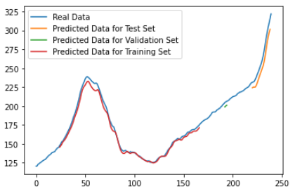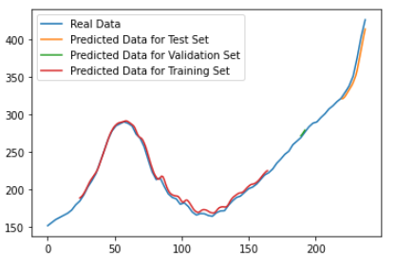

*Figure 1: Tampa Model Figure 2: St. Pete / Clearwater Model*

**LSTM-Based Neural Network Optimization (Multivariate Time-Series Data)**

***Table 4:*** *Hyperparameter Tuning for Fundamental Data LSTM Model*

| Trial | Batch Size | Epochs | Learning Rate | Layers(Stacked) | Unit Layers | Optimizer | Dropout | Patience | TEST  RMSE | PREDICT  RMSE |
| --- | --- | --- | --- | --- | --- | --- | --- | --- | --- | --- |
| 1 | 64 | 500 | 0.01 | 4 + 5 Dense | 200 | SGD | 0.5 | 50 | 21.565 | 12.38 |
| 2 | 64 | 500 | 0.01 | 4 + 1 Dense | 200 | SGD | 0.5 | 50 | 48.18 | 30.16 |
| 3 | 64 | 500 | 0.01 | 4 + 1 Dense | 300 | SGD | 0.5 | 30 | 52.32 | 32.98 |
| 4 | 32 | 500 | 0.01 | 4 + 3 Dense | 300 | SGD | 0.5 | 30 | 35.27 | 20.47 |

**GRU-Based Neural Network Optimization (Multivariate Time-Series Data)**

***Table 5:*** *Hyperparameter Tuning for Fundamental Data GRU Model*

| Trial | Batch Size | Epochs | Learning Rate | Layers(Stacked) | Unit Layers | Optimizer | Dropout | Patience | TEST  RMSE | PREDICT  RMSE |
| --- | --- | --- | --- | --- | --- | --- | --- | --- | --- | --- |
| 1 | 32 | 500 | 0.01 | 4 + 5 Dense | 500 | Adam | 0.5 | 50 | 34.45 | 20.48 |
| 2 | 32 | 500 | 0.01 | 4 + 3 Dense | 300 | SGD | 0.5 | 50 | 43.22 | 25.22 |
| 3 | 32 | 500(59) | 0.001 | 4 + 5 Dense | 200 | Adam | 0.5 | 30 | 33.53 | 19.76 |
| 4 | 32 | 500 (78) | 0.001 | 4 + 5 Dense | 350 | Adam | 0.5 | 30 | 35.25 | 20.36 |